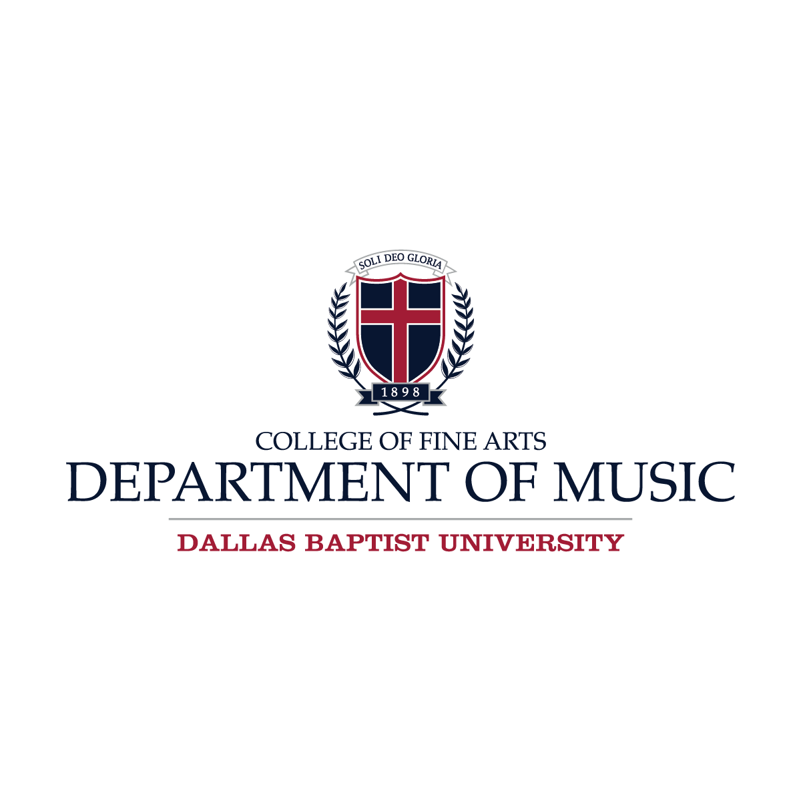

JUNIOR VOICE RECITAL

FIRST LAST, soprano

FIRST LAST, collaborative pianist

Tuesday, September 16, 2025 7:30 p.m. Rogers Theater
PROGRAM

I.
MAJOR WORK (IF FROM ONE)
<Selection Title> <Composer Name> (<Composer Dates>)

II.
MAJOR WORK (IF FROM ONE)
<Selection Title> <Composer Name> (<Composer Dates>)

This recital is given in partial fulfillment of the requirements for the degree
<ex. Bachelor of Music in Vocal Performance. Mr. or Ms. ________. is from the studio of ________.
Please silence all cell phones and electronic devices.

Join us for upcoming College of Fine Arts Events! www.dbu.edu/cofaevents

